Business Case F1nance
Introduction
Business Case Conceptual Structure | Definitions
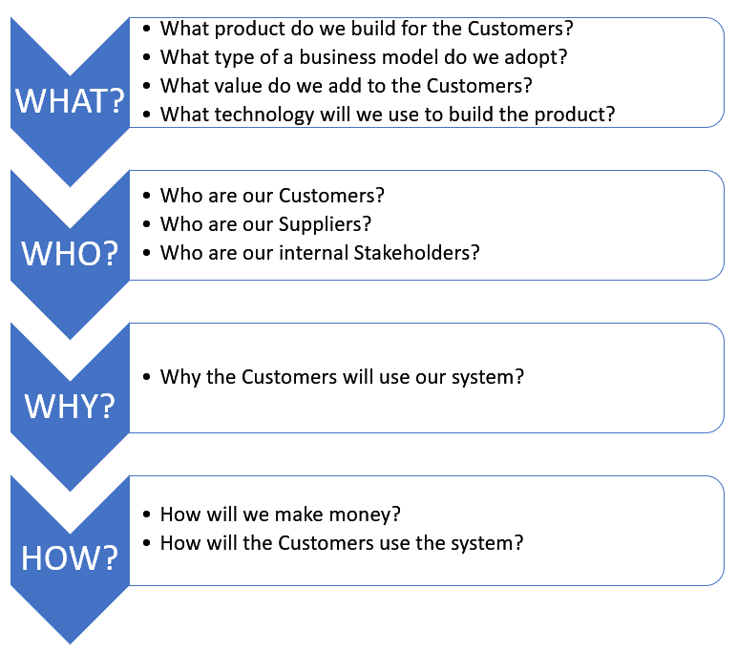 | Customer:  A customer is an individual or business that purchases another company's goods or services.  Customers are important because they drive revenues; without them, businesses cannot continue to exist.  Supplier:  A supplier is a person, business, or entity that provides products, data or services to another entity.  Stakeholder:  A person with an interest or concern in something, especially a business.  Stakeholders encompass all individuals or groups who have a vested interest in the performance of the business.  Business Model:  The term business model refers to a company's plan for making a profit. Examples: Freemium, Subscription, Advertising, etc.  Distribution Channel:  A distribution channel is a path that a product or service could take on its way to market. What's a direct distribution channel? A direct distribution channel is one where a company sells directly to the consumer, usually through their website or retail store.

Team No: 2
Application Name: F1nance
The business case should be documented by completing the table below (Answers column).
Category | BC Section | Questions | Answers
WHAT? | Product Overview | Give a brief description of the proposed software product. | A personal finance platform designed for F-1 visa holders in the United States. It provides budget tracking tools, compliance-aware guidance on work and tax regulations, and culturally relevant financial education.
 | Value Propositions | What Customer business needs are we satisfying? | It should solve the lack of U.S. financial system knowledge among international students. It could also provide compliance guidance for visa restrictions (e.g., work eligibility, tax obligations).
 |  | What value do we add to the Customers? | It could help improve budgeting for tuition, rent, and living expenses. It also offers AI-driven personalized advice, automated document parsing, and forecasting.
 | Type of Business Model | What type of a business model do we adopt? | Freemium: An SaaS provides free access for core budgeting and education. Premium subscription for advanced features (AI-based coaching, tax prep assistance, personalized forecasts). Additional revenue from affiliate partnerships and university licensing.
 | Key Resources | What Key Resources do our value propositions require? | We should have the following key resources:  - Development team for software and AI modules.  - Financial and legal experts specializing in F-1 regulations.  - Data providers for tax, banking, and exchange rates.  - Marketing and customer support staff.
 |  | What are our Distribution Channels? | We can utilize these channels to reach the targeted audience:  - App stores (iOS, Android).  - Direct web platform.  - University partnerships.  - Social media and international student forums.
 | Technology | What technology will we use to build the product? | Front-end technology: Next.js, TypeScript with necessary libraries (React Native if expanded to mobile)  Back-end technology: Python, FastAPI  Database: PostgreSQL  Hosting: AWS EC2  AI components: NLP chatbot for Q&A, machine learning for financial forecasting and recommendations, OCR for document processing
 |  | Is it a mobile or Web/desktop application? | It will be accessible via web portal first, expanding to mobile applications when reaching certain users.
 | Known Prototypes | What are the known prototypes of your product?  Reference some known portals on the Internet that are similar to your product. You will use these prototypes for developing business, user requirements. | List of Prototypes:  - Mint (budgeting).  - YNAB, Monarch Money, Pocket Guard (cash flow).  - Sprintax (international tax).  - NerdWallet (financial literacy).
WHO? | External Customers | Who are our Customers? | We will focus on international students under F-1 visa in the U.S as the primary users since they are the targeted audience. We can also have parents and guardians abroad kept in the loop.
 | External Suppliers | Who are our Suppliers?  Does the system exchange data with external systems? For example, banks, delivery contractors, restaurants, etc. | We need payment processors (Stripe, PayPal) to optimize user paying experience.  Financial APIs for account integration and currency conversion is also a must.  The product should also keep updating with tax form data providers.
 | Internal Stakeholders | Who are our internal Stakeholders?  Do we need a product development group?  Do we need a sales group?  Do we need a finance group (accounts payable, receivable)?  Do we need a customer support team?  Do we need an advertising management group? | We should have these internal Stakeholders in employment:  - Product development group  - Compliance/legal experts  - Marketing and sales team  - Finance/accounting team  - Customer support  Any individual or organization investing in the product would also be considered internal Stakeholders
WHY? | Expected Benefits to the Customer | Why do we believe our new product will be better than those already existing on the market? | Because no existing finance app directly integrates F-1 visa constraints into budgeting, tax, and compliance guidance. Mainstream tools like Mint or YNAB assume full work eligibility and lack features tailored to international students.
 |  | Why would the Customers want to use our system? | Customers will choose this system because it:  - Provides visa-aware financial advice, avoiding compliance errors.  - Uses AI to personalize guidance, automate document checks, and forecast expenses.  - Combines budgeting, education, and tax prep support in one platform.  - Reduces uncertainty for students adjusting to the U.S. financial system.  - Offers peace of mind parents and students cannot get from generic tools.
HOW? | System Use | How will the External Customers use the system?  What is the main system use scenario for the External Customers? | They can use the system by signing up, entering income/expense data, linking bank accounts, and uploading documents. They’ll receive personalized budgets, visa-compliant financial advice, tax guidance, and savings forecasts.  An F-1 student creates an account, inputs monthly stipend or part-time earnings, logs tuition and rent, connects a bank account, and uploads a W-2 or 1042-S. The system generates a budget, flags visa-related work/tax restrictions, and provides forecasts for tuition savings.
 |  | What is the main system use scenario for the Internal Users? | Internal staff update compliance rules, curate financial education content, handle support requests, monitor system performance, track subscription revenue, and manage affiliate/university partnerships.
 | Revenue Generation, Revenue Streams | How will we make money?  Such as Subscription fees, renting, leasing, licensing, brokerage fees, advertising sales, etc. | The main revenue stream would be generated via premium subscription (Freemium business model). We can also gain revenue via these channels when the product grows to a certain scale:  - Affiliate commissions (banks, tax prep services, insurance).  - Institutional licensing for universities.  - Targeted advertising for student-relevant services.

